Article Outline Sept 2009 – The Inquiry Newsletter

Masthead – The Inquiry

- Letter from President
- Deepen the Leadership Conversation with Your Clients
- Co-active Network News
- So You Think You Can Dance?
- Upcoming Events
- We’re Wading into Social Media
- Technical Comments

The morning sun is as warm and golden as honey as it pours through my office window. I love Fall. It feels as if the earth is winding down, settling from all the bursting forth of Spring and the rich harvest of late Summer. I find myself in deep appreciation of the constancy of change and filled with gratitude for the rich tapestry of my life.

When I am able to relax into the state or condition rather than just listing the things for which I am grateful, gratitude is the most healing thing I know.

In this state of gratitude, I find that I am able to let go of my worrying mind and of the judge within that evaluates things as good or bad. Whatever comes is a gift to be embraced and savored. Quite separate from any circumstances, there is ease, flow and true freedom.

Of course I am not able to reside permanently in this state of gratitude. It requires a consistent practice of finding myself captured in reaction and/or judgment to “recover” to this state of gratitude. The recovery can happen in an instant. Often it takes hours and sometimes days. As I practice, I find that little by little, the times of reaction are growing shorter and the state of gratitude longer. Hooray!

I am not a master of this practice, not by any stretch of the imagination. And yet I sense that the practicing is enough. It is the intention, rather than the perfection of this practice that is so incredibly healing.

In fact, the more challenging the circumstances, the more I fail and recover, the stronger my intention becomes. Thus it is the failure and falling away (and the ensuing recovery) that strengthens me, not an illusion of perfection.

This is my wish for the world. . .this practice of recovering to a state of gratitude. I know this isn’t a particularly new or novel concept and yet I sense that it is important. With each passing year, the challenges facing human kind grow more complex. What if the key lay, not only in what we did, in the brilliant solutions that we were able to discover together, but also in our state of being while we were doing it? In this way, perhaps the simple practice of recovering to the state gratitude could shift everything.

Love, Karen

Karen Kimsey-House
President

Deepen the Leadership Conversation with Your Clients

The Leadership Circle (TLC) is a powerful set of coaching tools which will help you uncover the leadership competencies your clients possess, where their strengths and weaknesses lie, and identify areas of limiting belief. If your practice includes corporate clientele or you are looking for a path into that lucrative market, we invite you to become a part of our charter group of organizational and leadership transformation architects. Seats in remaining 2009 programs are limited.

When Co-active Coaching and TLC work together, something completely different is created in the marketplace: the art and science of transformative leadership are combined. The art of the Co-active conversation is empowered by the science in TLC’s framework and philosophical approach giving you a validated platform for creating transformative work inside organizations.

Personal Benefits – What’s in it for Me?
Experiencing The Leadership Circle Profile® assessment process personally gives you a clear perspective on your own leadership capabilities, strengths, weaknesses, and gifts. Greater personal awareness builds understanding around what makes a good leader. The program provides rigorous academic learning around leadership in a condensed and impactful way. Learning underlying leadership development theory through this tool is a powerful complement to the Co-active curriculum and the investment you’ve already made in yourself.

Professional Benefits – What’s in it for My Business?
TLC tools trigger breakthrough conversations with clients, coaches who have already built The Leadership Circle Profile into the discovery process with clients report that they get to core, deep conversations much faster. This accelerated process creates profound coaching outcomes that are deeply satisfying to a coach and very powerful for the client. The Profile process immediately surfaces issues to work with, allowing the client to achieve improvement quickly.

TLC has been used, vetted and validated by hundreds of U.S. governmental agencies, non-profit organizations, global corporations, and major universities. TLC provides you with credibility in the competitive world of organizational and executive coaching by bringing demonstrable leadership expertise to your coaching. The Co-active coaching and TLC combination provides an end-to-end business system for positioning, marketing, differentiating, and executing on your coaching services.

A rarity in coaching engagements, the instrument can be used to generate reportable, measurable results. By administering the Profile at the beginning of an engagement and at key points during the process, you can track progress at both the individual and organizational levels. Composite reports and a culture survey bring added value to organizational coaching efforts.

TLC helps you to become competitive in the marketplace and sets your practice apart by bringing credibility, measurable expertise, and effective transformation techniques to your business. TLC certified coaches disclose overwhelmingly positive client feedback paired with healthy earnings. Is The Leadership Circle certification program right for your business? Learn more about our TLC certification program.

Registration for this three-day program is by phone only. Remember, seating is limited. Contact a Program Advisor at 1.800.691.6008 to register today.

Remaining 2009 Programs:
October 19-21 in Washington, DC; Registration Deadline: September 28
November 17-19 in London, UK, Registration Deadline: November 2

Co-active Network News

Managing Daily Digests
If you are active in several communities on the Co-Active Network, you may find yourself on the receiving end of many daily digests. Did you know you can turn off the daily emails from individual communities?

Login to http://www.coactivenetwork.com then click on the "Manage Account" link near the top of the green box at the left edge of screen. Here you will find a list of communities you are joined to under the heading "My Communities." You will see two columns of boxes, one labeled "Daily Digest," and the other labeled "Real-time Notifications."

If you do not want any email from a community, uncheck both boxes to cease email delivery for that community. If you want a summary of each day's activities sent to you once per day, check the box for "Daily Digest." (This is the default when you join any community.) If you want to receive an email as soon as somebody posts or responds, check the box for "Real-time Notifications." Finish by clicking the "Save Changes" button.

If you are traveling and want to temporarily halt all daily digest emails from the Co-Active Network, check the "Suspend Mail" box on the "Manage Account" screen. This will stop all email from every community you are joined to until you return and remove the check in the box. Don't forget to click the "Save Changes" button to make your changes stick.

Members in the News
There are many ways that Co-Active coaches have taken the Co-Active message out into the world. Coaches have been written up in newspapers, interviewed on the radio and appeared on television. Have you visited the folder in the Resources area highlighting Network Members in the News? This folder has links to newspaper articles, radio recordings and news video featuring Co-Active Network members. Congratulations to all!

In addition to celebrating the success of our members, this resource also serves as a learning tool. Explore the materials and learn how coaching principles become interesting articles and interview topics. Look for the spin. Absorb how your fellow coaches apply coaching ideas and techniques to a wide variety of topics. Even dare to imagine how you might answer the questions posed.

Have you been published, recorded or taped by a news or media outlet discussing a coaching topic during 2009? Please send information and links about your publicity and news successes to networksupport@thecoaches.com. We might publish it in "Members in the News" to share with the community.

Warmly,
Marcia Norris, Co-Active Network Liaison
networksupport@thecoaches.com

Main Community Call Schedule for Fall

Hope is Not a Marketing Strategy
Thursday, September 24, 2009 at 1 pm PT/4 pm ET
Event led by Marla Skibbins, MCC, CPCC, and Meade Dickerson, MCC, CPCC, of MyFullPractice.com.
Do you hope you will get clients but are not sure how they will come to you? Do you wonder how to transform yourself from trained coach to a coaching business? Do you wish and dream you had more revenue flowing into your business? This teleclass will help you move from “hoping” for clients to “knowing” you will get clients. Learn to shift from passive marketing to proactive marketing. This teleclass will supply you with more ideas than you will ever use. Register now.

What's Stopping You from Getting Clients... and What to Do About It
Wednesday, October 14, 2009 at 11 am PT/2 pm ET
Event led by C.J. Hayden, MCC, CPCC, the best-selling author of Get Clients Now!, Get Hired Now!, and The One-Person Marketing Plan Workbook. Find out more about C.J. at GetClientsNow.com.
What are the barriers that prevent talented coaches from building a thriving business? You can overcome these challenges and attract more clients with less effort by making a few simple changes. Learn how you may be sabotaging your own marketing, the three most reliable ways to build your business quickly, when Internet marketing is a useful tool and when it won't help you, and how to build a system to make marketing simple and effortless. Register now.

If you have questions on a Co-Active Network technical issue or comments on other Network topics, please email networksupport@thecoaches.com.

So You Think You Can Dance?

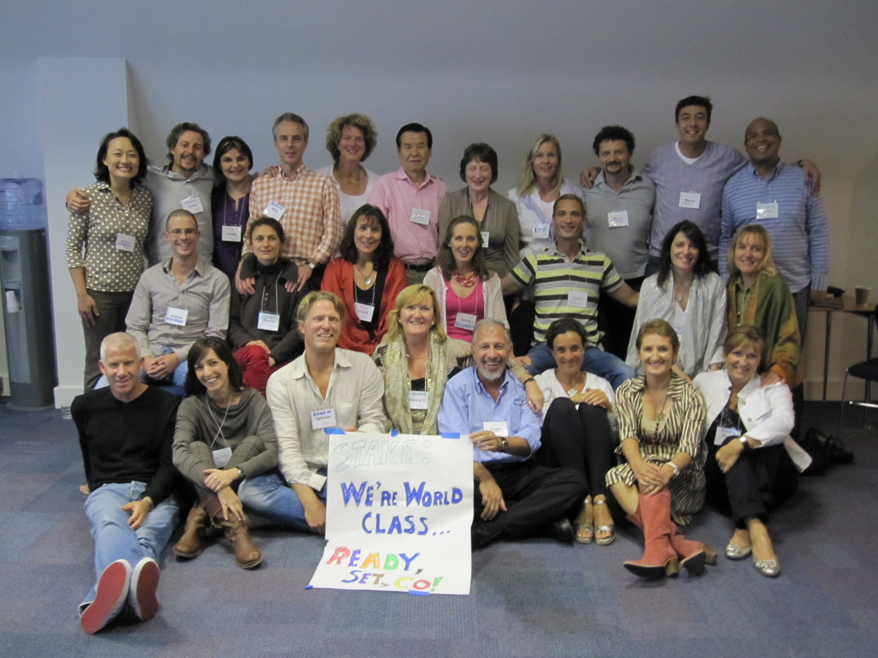
In recent newsletter issues we’ve let you in on the audition process and outcomes for selecting new course leaders for our growing programs outside the United States. The 22 new international leaders from Dubai, France, South Africa, Israel, South Korea, Germany, UK, Spain, Belgium and The Netherlands who have been chosen as leaders over the past 18 months gathered in London two weeks ago for ‘Dance Camp.’

Because it is CTI’s commitment to provide world class training, all our course leaders go through a rigorous multi-phase training process. In addition to continually reviewing the content and approach of all our public coaching courses, CTI also reviews how course leaders are prepared to lead.

‘Dance Camp’ in London was a new program design. The intent is to provide a new level of mastery for leaders and teach them to effectively lead all the building blocks of the courses. If you haven’t figured it out yet, the name ‘Dance Camp’ reflects the goal of learning to dance with exercises, course participants, and other leaders.

Their stake? Ready. Set. Co! Sounds like a rally cry for all of us.

Upcoming Events

Women's Leadership Conference
October 2 & 3, 2009 in Chicago, IL
Join CTI-trained coaches and leaders for a special 2-day event with keynote speaker Marianne Williamson.

Women are called to guide the generations of today and tomorrow, at work and at home: dreaming, striving, learning, teaching and creating. To see and shape the world from our best, most authentic selves, we must draw on the guidance and experience of the wise women around us. In them, we may see and then believe in ourselves.

Learn more about the Conference at http://www.thespiritofleadership.net/.

International Conference of Co-Active Leadership Graduates
All Tribes. All Years. All Countries. Together we will change the world!
October 9th-11th 2009, New York City
All CTI Leadership Graduates are invited to Danielle White’s Leadership project, The International Conference of Co-Active Leadership Graduates featuring guests Henry Kimsey-House, L.A. Reding, and Kulu and co-led by Danielle White and Rick Tamlyn. It’s time for Co-active leaders to join together internationally to create their own way to move forward in the world!

A selection of Leadership graduates will share their projects and experiences with us. Under the umbrella of ‘Co-Active Leadership’, the first day will focus on Inspiration, the second day will focus on Sustaining Success and the third day will be on Legacy. We are mixing together intangible inspiration with practical skills and tools.

To listen to an information call about the event or to register for the conference, visit http://www.leadershipgraduates.com/.

Recovering to Wholeness
October 14, 2009 in San Francisco, CA
We warmly welcome you to join us for an inspiring evening of poignant insights with CTI’s President and Co-Founder, Karen Kimsey-House. Mark your calendar for this very special event!

Events of the past year have shaken us all loose from ‘business as usual’ and provided a spectacular moment of global consciousness. We are beginning to see clearly that as residents of this planet, we are profoundly and inextricably interdependent. Much of the foundation of what we know is shifting leaving us all unusually free to improvise a fresh course forward.

Leaders from every realm of our world, business, secular and spiritual have acknowledged this time as one of great transition and potential transformation. It is a time of powerful choice where we will either be dominated by the circumstances or be shaped and changed by the challenges that face us.

People everywhere are longing to connect heart to heart, beyond culture, language and ideological differences. And there is a leader inside each of us, reaching to impact the world around us, longing to nourish this unfolding story of collaboration, connection and wholeness. Please join CTI co-founder Karen Kimsey-House for an evening of exploration and inspiration. As a leader and coach, what will you choose to create from this time?

Event details available from the San Francisco ICF Chapter.

We’re Wading into Social Media

Do you know of anyone who hasn’t read about the impact of social media and the rise of tools like Twitter or Facebook? At CTI, we’ve been watching this growth and have noticed how many in our community have embraced this mode of communication. This fall, we’re wading into the media stream.

We’ve set up Facebook and Twitter accounts and we’re launching a blog as well. We’re looking for smart ways to extend our community, to connect with both our alumni and new students, and to keep up-to-date on what everyone is doing. We’ll be sharing coaching-related content which we hope will be of interest to you and valuable to forward to clients or colleagues.

We’re also looking forward to our new blog. Karen will post her thoughts and give updates on her various travels and speaking engagements. Perhaps even some guest posts. More on that soon.

And just to be clear, we’re not replacing the Co-Active Network with any of this. Instead, we see this as an opportunity to bring more people into the coaching conversation.

If you haven’t been there yet, please visit our Facebook page to become a “Fan” or visit our Twitter profile and follow us--we’ll follow you back. Let’s continue our dialogue online and would love your ideas and activity on how to make this interaction valuable for all. See you on Twitter and Facebook.

[TWITTER and FACEBOOK VISUAL ICONS?]

Technical Comments

Apologies upfront if you have received this newsletter in error. We have recently merged some databases and are in the process of updating our database software and the methods by which we handle opt-out requests. We know that some of our unsubscribe data has been lost during these multiple procedures.

If you wish to unsubscribe from “The Inquiry” quarterly newsletter from CTI, please use the link provided at the bottom of the screen. This action will remove you from the newsletter mailing list only.

